Theme: God of All Comfort (Mt 5:1-16)

Song 1 - God is For Us
Song 2 - The Lord is My Salvation
Kids' Song - Mighty, Mighty Saviour
Song 3 - Speak O Lord
Closing Song - Grace and Peace

God is For Us by CityAlight

[Intro]
|D / / /|G / / /|
|D / / /|G / / /|

[Verse 1]
D G D
We won't fear the battle, we won't fear the night
G D Bm A
We will walk the valley with You by our side
D G D
You will go before us, You will lead the way
G D Bm A
We have found a refuge, only You can save

[Chorus]
D G D
Sing with joy now: our God is for us
G D Bm A
The Father's love is a strong and mighty fortress
D G D
Raise your voice now, no love is greater
G D A
Who can stand against us if our God is for us

[Intro]
|D / / /|G / / /|

[Verse 2]
D G D
Even when I stumble, even when I fall
G D Bm A
Even when I turn back, still Your love is sure
D G D
You will not abandon, You will not forsake
G D Bm A
You will cheer me onward with never-ending grace

CHORUS

[Intro]
|D / / /|G / / /|
|D / / /|G / / /|

[Bridge]
G A
Neither height nor depth can separate us
Bm D/F#
Hell and death will not defeat us
G A
He who gave His son to free us
Bm A
Holds me in His love
G A
Neither height nor depth can separate us
Bm D/F#
Hell and death will not defeat us
G A
He who gave His son to free us
Bm A
Holds me in His love

CHORUS X2

[Outro]
|D / / /|G / / /|
|D / / /|G / / /|

[End]
D

Intro:
F# F# D G G G
F# F# D G G G
The Lord is My Salvation (A)
[Intro]
A D A D

[Verse 1]
F#m D Esus E
The grace of God has reached for me
F#m D Esus E
and pulled me from the raging sea;
D/F# E/G# A A/C# D
and I am safe on this solid ground,
Bm7 E D/A
the Lord is my salvation.

[Verse 2]
F#m D Esus E
I will not fear when darkness falls,
F#m D
His strength will help me scale these
Esus E
walls;
D/F# E/G# A A/C# D
I'll see the dawn of the rising sun,
Bm7 E D/A A/E
the Lord is my salvation.

[Chorus]
E D A/C#
Who is like the Lord our God,
E D A/C#
strong to save, faithful in love?
F#m E/G# A A/C# D
my debt is paid, and the victory won;
Bm7 E A E A E
the Lord is my salvation.

[Verse 3]
F#m D Esus E
My hope is hidden in the Lord,
F#m D Esus E
He flowers each promise of His word;
D/F# E/G# A A/C# D
when winter fades, I know spring will come,
Bm7 E D/A A/E
the Lord is my salvation.

[Verse 4]
F#m D Esus E
In times of waiting, times of need,
F#m D Esus E
when I know loss, when I am weak,
D/F# E/G# A A/C# D
I know His grace will renew these days;
Bm7 E D/A A/E
the Lord is my salvation.

CHORUS
A no intro
[Verse 5]
F#m D Esus E
And when I reach my final day,
F#m D Esus E
He will not leave me in the grave;
D/F# E/G# A A/C# D
but I will rise, He will call me home.
Bm7 E D/A A/E
The Lord is my salvation.

CHORUS

[Bridge] x2
D A/C# E/G# F#m
Glory be to God the Father,
D A/C# E
glory be to God the Son,
D A/C# C#m F#m
glory be to God the Spirit;
Bm7 Esus Asus
the Lord is our salvation.
CHORUS
[Bridge 2nd time ending]
Bm7 Esus F#m E D A/C#
the Lord is our salvation.
Bm7 E F#m E D A/C#
The Lord is our salvation,
Bm7 E A D A
the Lord is our salvation.
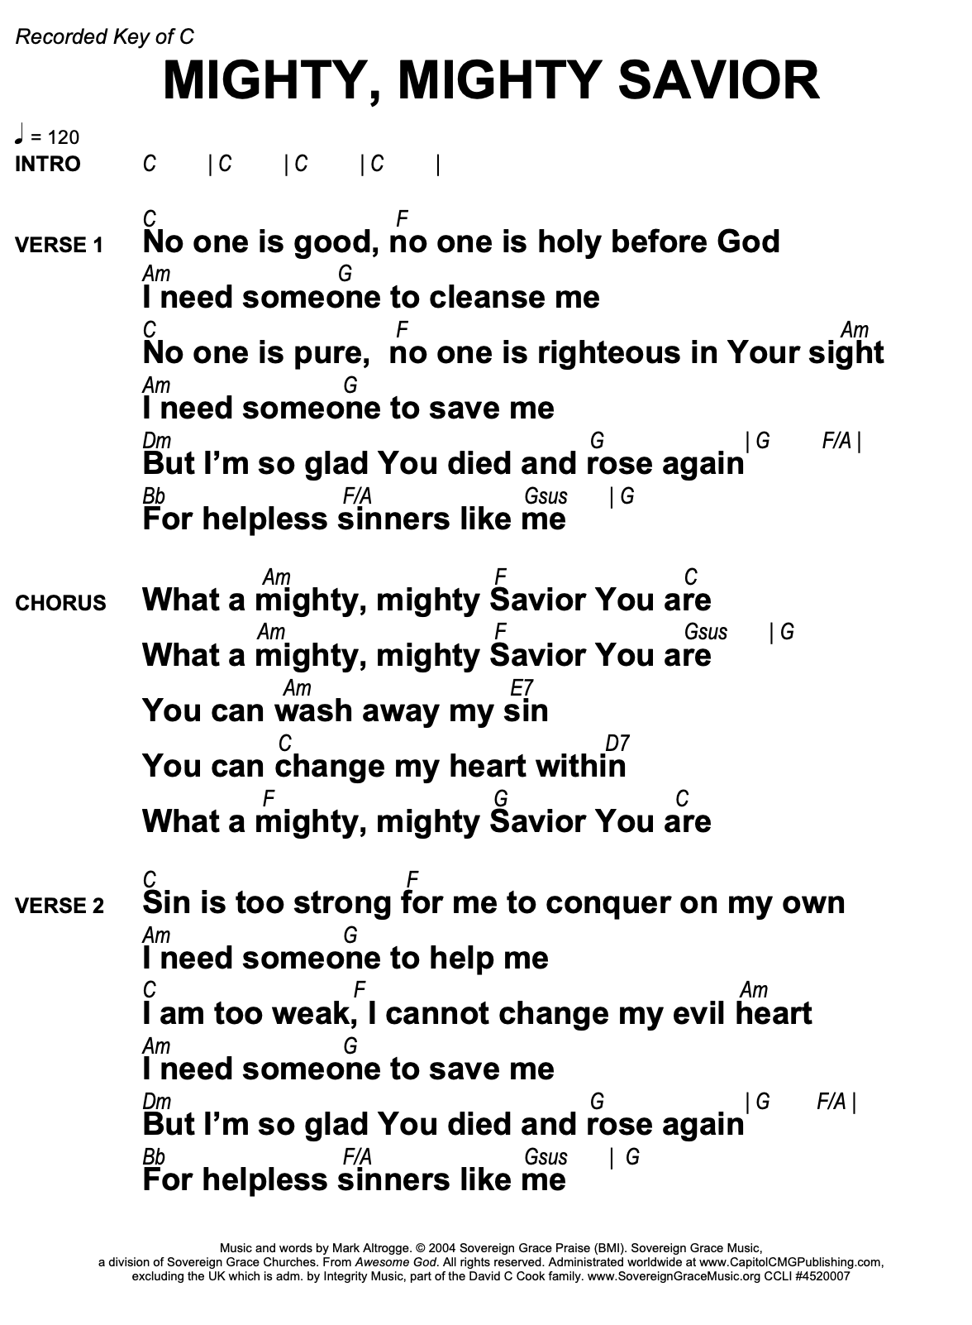
SPEAK O LORD

D E A D A/C#
Speak, O Lord, as we come to You
D A/C# F#m E
To receive the food of Your Holy Word.
D E A D A/C#
Take Your truth, plant it deep in us;
D A/C# E A
Shape and fashion us in Your likeness,
E E/D A/C# D A/C#
That the light of Christ might be seen today
E E/D A/C# D E
In our acts of love and our deeds of faith.
D E A D A/C#
Speak, O Lord, and fulfill in us
D A/C# E A
All Your purposes for Your glo ry.

D E A D A/C#
Teach us, Lord, full obedience,
D A/C# F#m E
Holy reverence, true humility;
D E A D A/C#
Test our thoughts and our attitudes
D A/C# E A
In the radiance of Your purity.
E E/D A/C# D A/C#
Cause our faith to rise; cause our eyes to see
E E/D A/C# D E
Your majestic love and authority.
D E A D A/C#
Words of pow'r that can never fail—
D A/C# E A
Let their truth prevail over unbelief.

D E A D A/C#
Speak, O Lord, and renew our minds;
D A/C# F#m E
Help us grasp the heights of Your plans for us—
D E A D A/C#
Truths unchanged from the dawn of time
D A/C# E A
That will echo down through eternity.

E E/D A/C# D A/C#
And by grace we'll stand on Your promises,
E E/D A/C# D E
And by faith we'll walk as You walk with us.
D E A D A/C#
Speak, O Lord, till Your church is built
D A/C# E A
And the earth is filled with Your glory.

Grace and Peace by Sovereign Grace

VERSE 1
C Am
Grace and peace, oh how can this be
G
For lawbreakers and thieves, for the
Am F
worthless, the least
C Am
You have said that our judgment is death
G Am F
For all eternity without hope, without rest
F Am G F
Oh, what an amazing mystery,
Am G F
what an amazing mystery
G C…
That Your grace has come to me

…C Am|F |C Am | F

VERSE 2
C Am
Grace and peace, oh how can this be?
G Am
The matchless King of all paid the blood
F
price for me
C Am
Slaughtered lamb, what atonement You bring!
G
The vilest sinner's heart can be
Am F
cleansed, can be free
F Am G F
Oh, what an amazing mystery,
Am G F
what an amazing mystery
G C…
That Your grace has come to me

…C Am | F | C Am | F

VERSE 3
C Am
Grace and peace, oh how can this be?
G Am
Let songs of gratefulness ever rise,
F
never cease
C Am
Loved by God and called as a saint
G Am
My heart is satisfied in the riches of
F
Christ
F Am G F
Oh, what an amazing mystery,
Am G F
what an amazing mystery
G F
That Your grace has come to me

Am | G C | F Am | G

TAG
C F Am
Oh, what an amazing love I see, what an amazing love I see
G
That Your grace has come to me
OUTRO F Am | G C | F Am | G
F Am | G C | F Am | F | C
X

